14 - A Portfolio wise validation should be implemented while uploading the claim xml file

Checking with below mentioned portfolios

MUDNEWM20252026C

CP2 - Claim 1

CustomersId | LoanAccountNumber | PrincipalAmountAsOnDateOfNPA | RecoveryNPAPrincipalAmount | OTS | UnrecoveredInterestAsOnDateOfNPA | TotalOutstandingAmountAsOnDateOfNPA | DateOfNpa
CR13Q1252603 | CR13Q1252603 | 15000 | 0 | N | 200 | 300 | 01-04-2026
CR13Q1252604 | CR13Q1252604 | 16000 | 100 | N | 200 | 300 | 01-04-2026
CR13Q1252605 | CR13Q1252605 | 17000 | 1000 | N | 200 | 300 | 01-04-2026
CR13Q1252606 | CR13Q1252606 | 18000 | 1100 | N | 200 | 300 | 01-04-2026

CP2 - Update

custid | acctno | Convert to
CR13Q1252603 | CR13Q1252603 | Standard

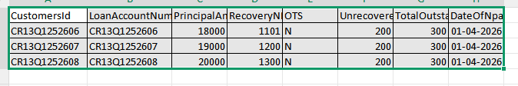

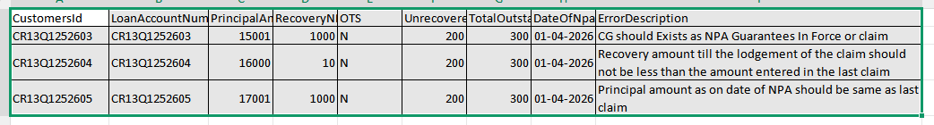

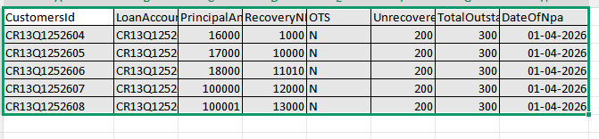

CP3 - Update

custid | acctno | Convert to
CR13Q1252603 | CR13Q1252603 | NPA

CP4 - claim

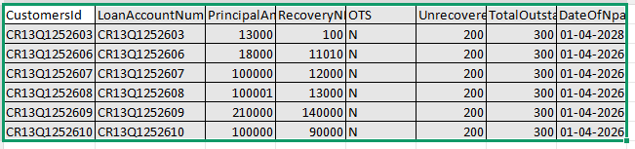

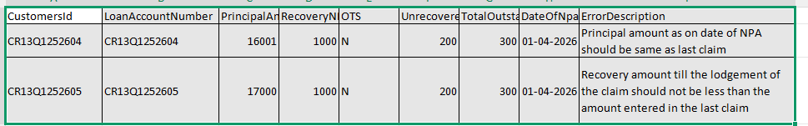

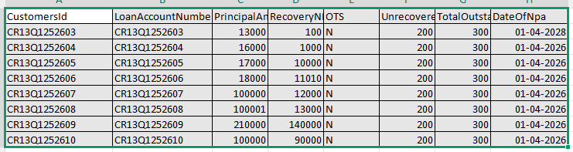

CP 6 - claim

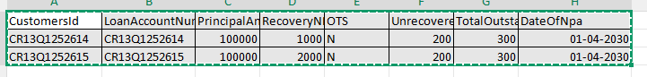

14 - B display the Type of claim ie, Interim claim1, Interim Claim2, Final claim, MP interim claim 1, MP interim claim2 and MP Final claim.

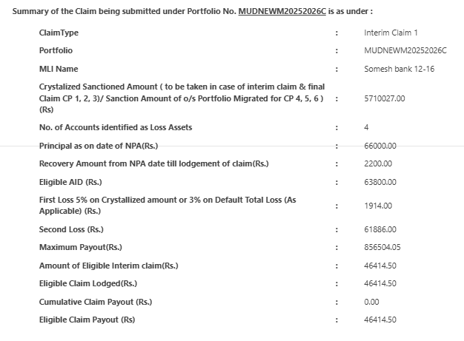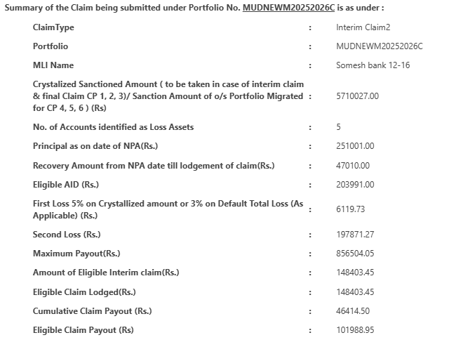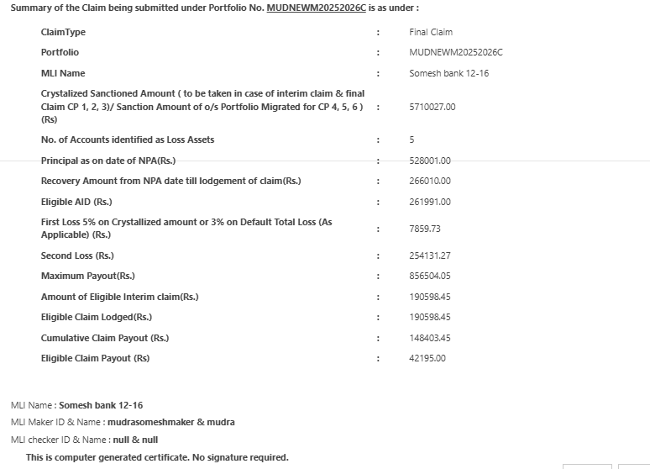

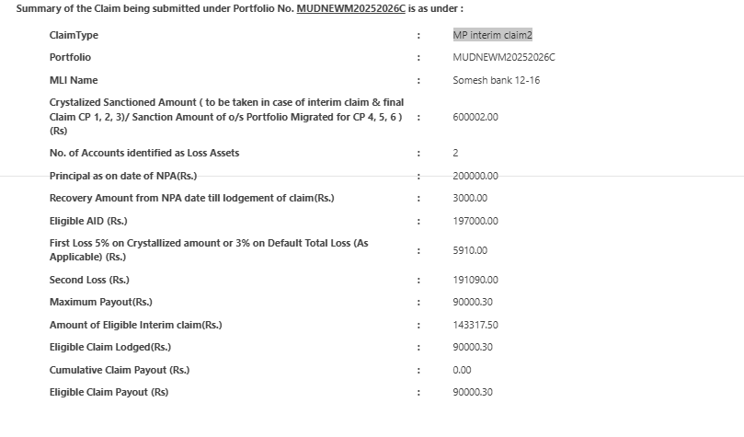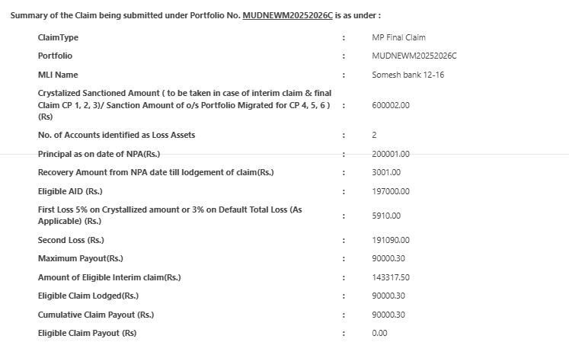

- C Valid Records’ from the claim file, NPA date should be included in valid records

Added NPA date column in both valid and invalid file
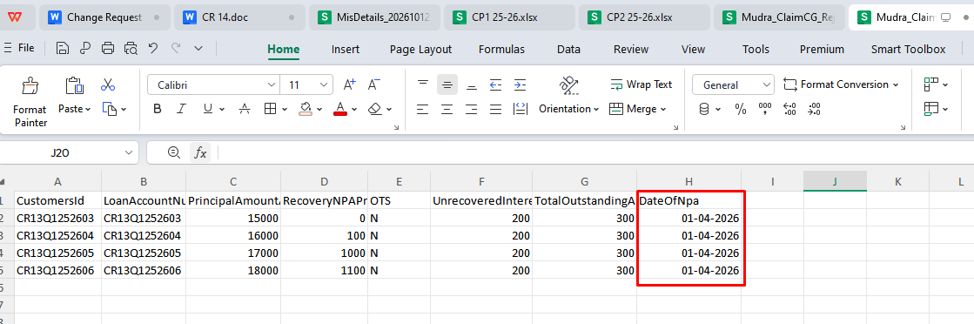

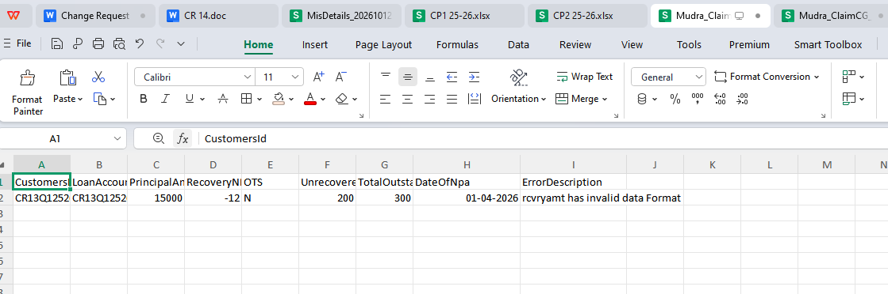

MUDNEWM20252026SHG

